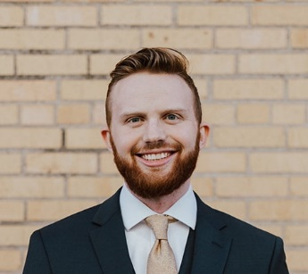Josiah W. Smith (S’18) was born in Denver, CO, USA in 1997. He received the B.S. degree (*summa cum laude*) in electrical engineering from The University of Texas at Dallas in 2019, where he is currently pursuing a Ph.D. degree in electrical engineering specializing in communications engineering. He was awarded the Texas Instruments Analog Excellence Graduate Fellowship in August 2019 and the Louis Beecherl, Jr. Graduate Research Fellowship in August 2021. During the summer of 2020, he developed real-time human-computer interaction algorithms for mmWave radar with imec-USA. In the summer of 2021, he developed advanced deep learning and data-driven algorithms for user experience enhancement at Apple in the Display Technologies group. His current research interests include hybrid-learning algorithms, new regime radar imaging algorithm development, ultra-wideband radar imaging algorithms, terahertz radar, radar perception, computer vision, deep learning, millimeter-wave sensing, and phased array signal processing.

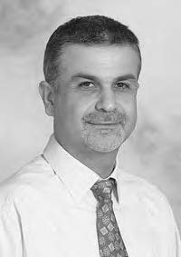**Murat Torlak** (SM’04) received the M.S. and Ph.D. degrees in electrical engineering from The University of Texas at Austin, in 1995 and 1999, respectively. Since August 1999, he has been with the Department of Electrical and Computer Engineering, The University of Texas, where he has been promoted to the rank of a Full Professor. He is serving as a Rotating Program Director at the U.S. National Science Foundation (NSF). His current research interests include experimental verification of wireless networking systems, cognitive radios, millimeter-wave automotive radars, millimeter-wave imaging systems, and interference mitigation in radio telescopes. He was the General Chair of Symposium on Millimeter Wave Imaging and Communications in the 2013 IEEE GlobalSIP Conference. He has served as an Associate Editor for the IEEE Transactions on Wireless Communications, from 2008 to 2013. He is a Guest co-Editor of IEEE JSTSP Special Issue on Recent Advances in Automotive Radar Signal Processing, 2021.